Zalaba Design - modern design furniture, office and home luxury accessories all customized by you.
MILANO, Italy
Zalaba Design is proud to announce that they will be exhibiting their new designs during Salone del Mobile at Via Tortona 30 in Milano April 12, 2016 - April 17, 2016.

Zalaba Design is a Zurich-based design studio specializing in interiors, exhibitions, and customized furniture design. They provide modern design furniture, office and home luxury accessories. Their mission is to design and create spaces. The family business has been active in the field of design for over 30 years. The company, now in its third generation, is managed by owner and designer Ginger Zalaba.
Bauhaus design influences the shape and materials of Zalaba’s exclusive furniture collection, KOLB. Through the use of high-grade materials, like the finest Italian leather, steel, and marble, as well as the application of sleek modern industrial design, Zalaba Design creates furniture for a lifetime. The KOLB designs can either be shipped in a flat pack or preassembled. With more than 500 possible color variations, each chair is made to order. Zalaba’s Italian artisan craftsmen can provide high-end, customized furniture and accessories worldwide within 1 – 5 months pretending on quantity and customization.

Ginger’s grandfather, Otto Kolb, was a Swiss-born architect and designer who taught design at the Illinois Institute of Technology in Chicago during the late 1940s. In addition to teaching, Mr. Kolb was commissioned to build several contemporary homes in the US, among them the Horner House in Illinois, which is listed in the National Register of Historic Places. Kolb was also honored with an award from the New York Museum of Modern Art. During the ‘50s and ‘60s, Kolb produced a limited edition of modern furniture. One of his chairs is on exhibit at the Louvre in Paris. Otto Kolb’s furniture has been featured in auctions held by both Sotheby’s and Quittenbaum. Built in the early 1980s, the Kolb House in Switzerland is still an important source of inspiration, as well as a fine example of modern and sustainable architecture.
“To be given the opportunity to work with Walter Knoll in Germany and exhibit in New York City at the renowned design gallery Hudson Furniture is a dream come true. We dedicate a reduction in design to showcase the essence of materials used, which exposes the purity of form and function – less is more.” Ginger Zalaba.

Contact:

Ginger Zalaba
ginger@zalaba.com
+41 79 868 88 18

Zalaba Design AG
Geisserweg 5,
CH-8306 Brüttisellen
www.zalaba.com

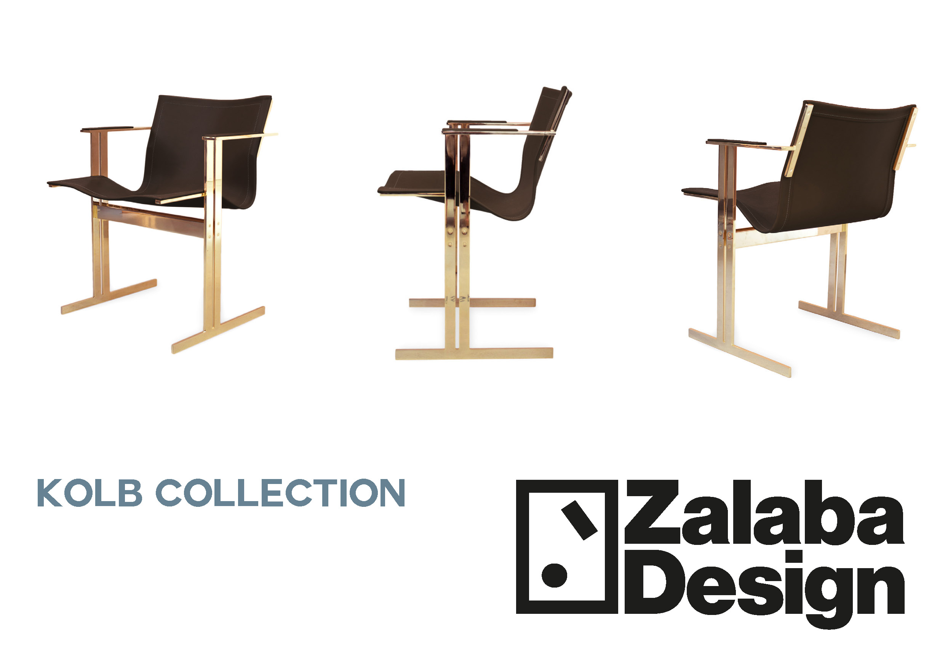

Kolb Dining Chair by Zalaba Design

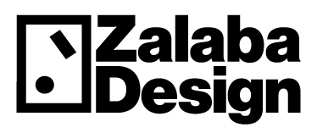

Logo


Ginger Zalaba owner and designer of Zalaba Design

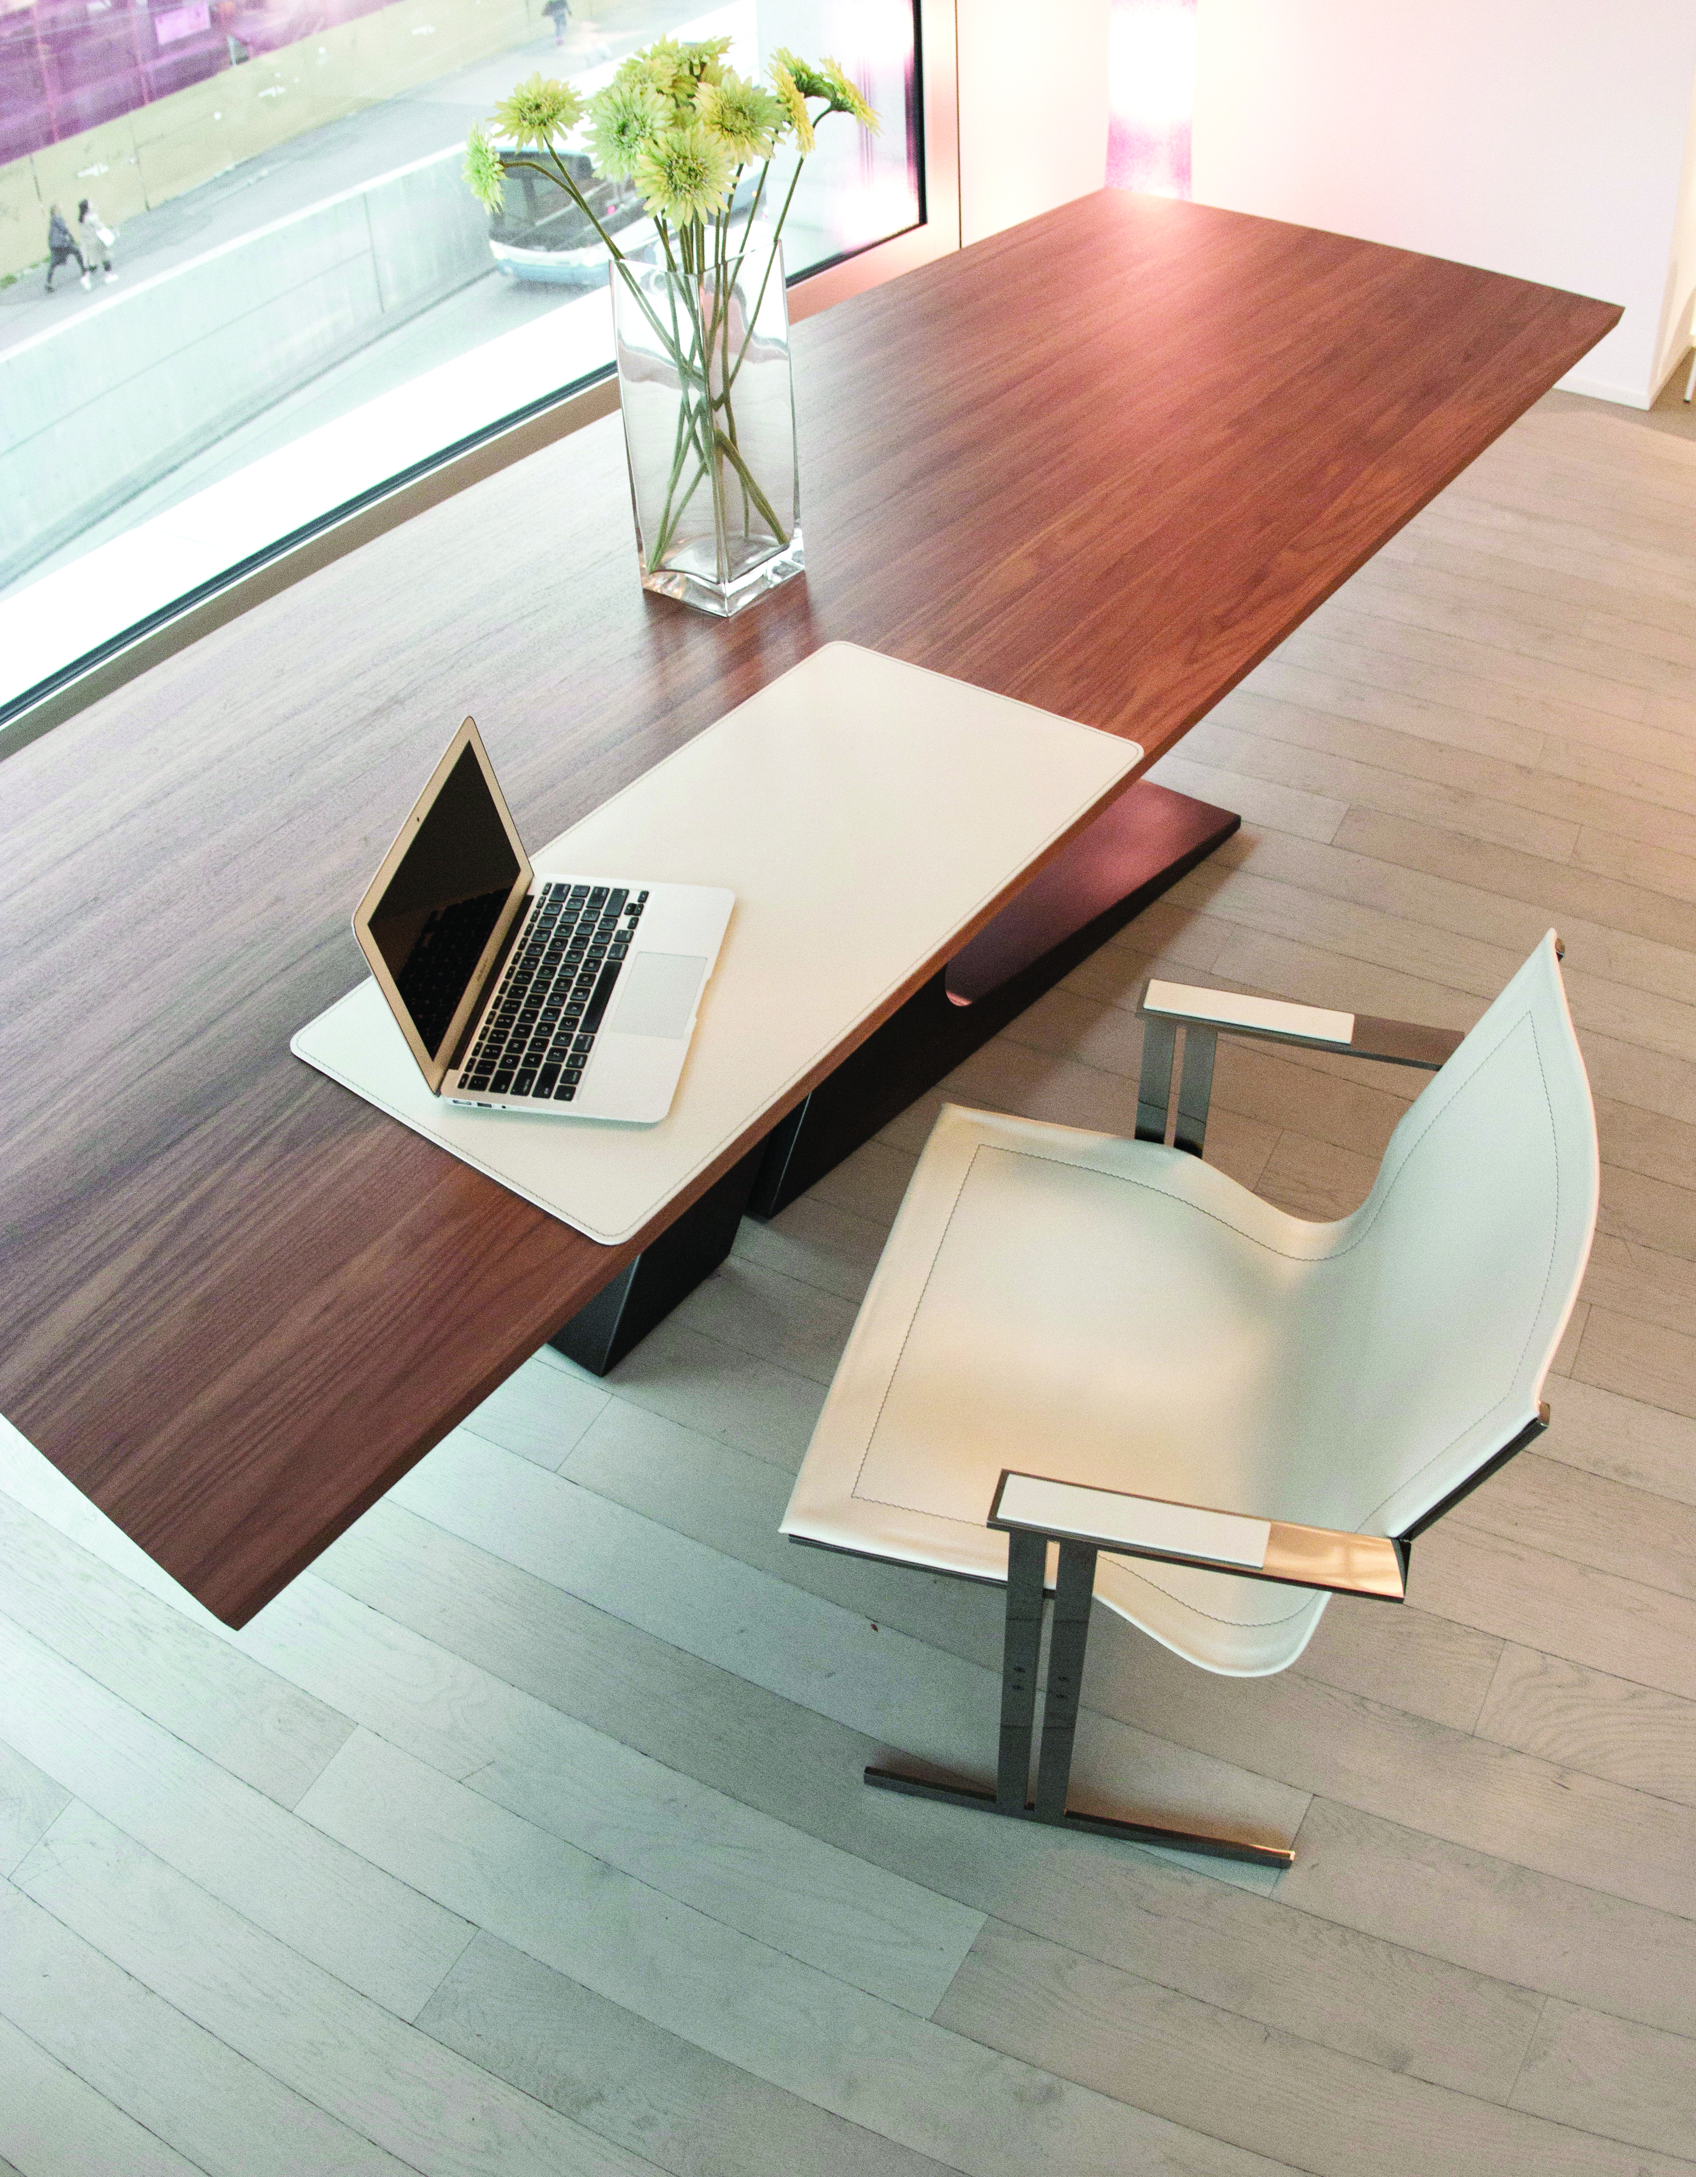

Kolb Office Collection by Zalaba Design

